Experiment No: 01
Name of the experiment: Implementing and Verifying Decoder (2 to 4)
Theory: A 2 to 4 decoder is a digital circuit that takes two binary inputs A0 A1 and generates four outputs D0 D1 D2 D3 based on the input combination. The four outputs each correspond to each binary sequence of inputs A0 and A1.
Truth Table:
A1 | A0 | D0 | D1 | D2 | D3
0 | 0 | 1 | 0 | 0 | 0
0 | 1 | 0 | 1 | 0 | 0
1 | 0 | 0 | 0 | 1 | 0
1 | 1 | 0 | 0 | 0 | 1

Taking Min terms of the outputs we get,
$$D0=A0^{'}.A1^{'}$$
$$D1=A0.A1^{'}$$
$$D2=A0^{'}.A1$$
$$D3=A0.A1$$
Circuit Diagram:
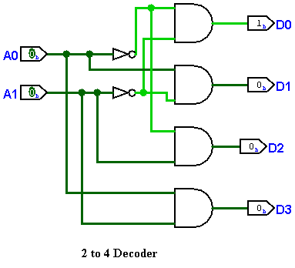
Output Images:
If $A0=0 \& A1=0$ Then $D0=1, D1=0, D2=0, D3=0$
If $A0=1 \& A1=0$ Then $D0=0, D1=1, D2=0, D3=0$
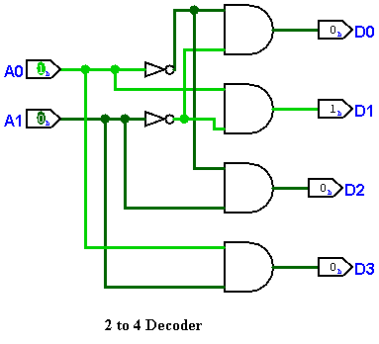
If $A0=0 \& A1=1$ Then $D0=0, D1=0, D2=1, D3=0$
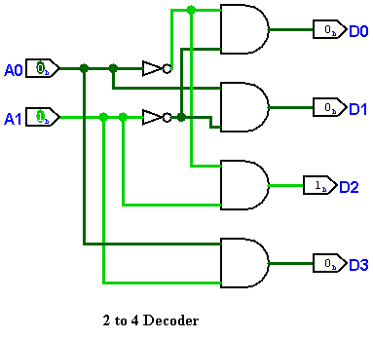
If $A0=1 \& A1=1$ Then $D0=0, D1=0, D2=0, D3=1$
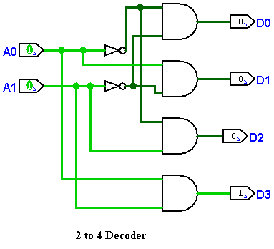
Conclusion: We can add an enable signal to control the circuit.

